Andrew Ng Coursera Neural Nets
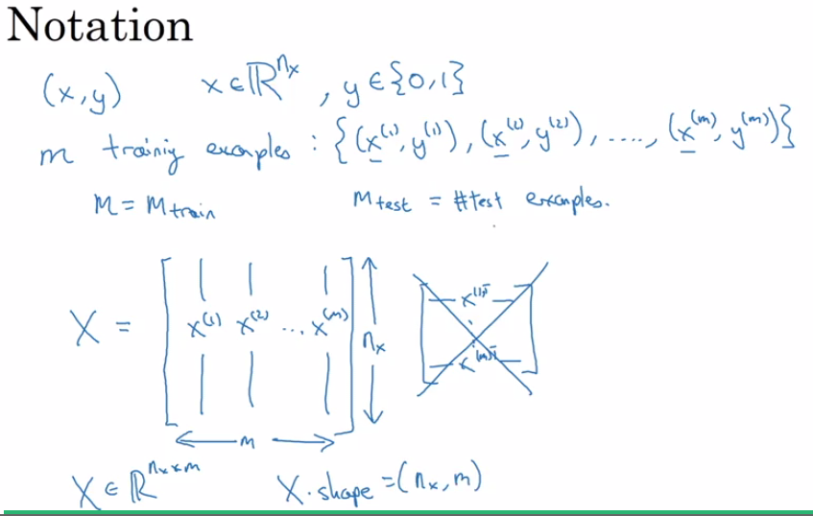

logistic regression is a means of making a linear regression technique interpretable by ML algos by restricting values to between 0 and 1, and making it differentiable

The cost function is the average of the ouputs of all the loss functions, which are applied to each individual example.

